DataBase Theory Apps

Name: [Paul Pezold](mailto:prp81640@ucmo.edu), Yuji Chang

Date: 4/27

Class: CS4600

**Project description**

Business context:

This app would be a part of a larger application environment. A company such as Google or Yahoo would provide it, similar to how Google provides Drive with all of its additional features like Docs. Users create data in the form of entries and indirectly by their activities, which the parent app could use either to train or as inputs into their own machine learning tools. This is profitable because it can lead to new insights in investment trader psychology and can help improve market predictions. The parent application would also likely support an actual trading platform, so actual transactions and their results would automatically be connected to the diary entries, though that feature is omitted from this project.

Purpose

For the customer, value is provided in that they can do market research, record their trading activities, and otherwise use the parent app’s features all in one location. The provider in turn receives valuable data.

What it needs:

Currently, there are many applications that allow you to trade, and others that allow you to market research. Some combine those features, but none that we are aware of provide those in addition to our diary feature in a user friendly package.

What it does:

Allows the user to record diary entries about the trades they make, and allows them to do market research to inform those trades from one location

**Database description**

Input data available:

Historical data on economic behavior, company behavior, and price fluctuations are easily available through different vendors. This app combines these many data sets in one location, and then also contains the user generated text data about their trades. In one place, this unique database offers many opportunities for analysis and use not available from other products.

Information stored:

The historical data mentioned above is stored in the database, and a fully implemented application would have a way to pull in more relevant current information at a user’s request. All of the user’s metadata is stored, and linked to their transactions by foreign key.

**ER Diagram**

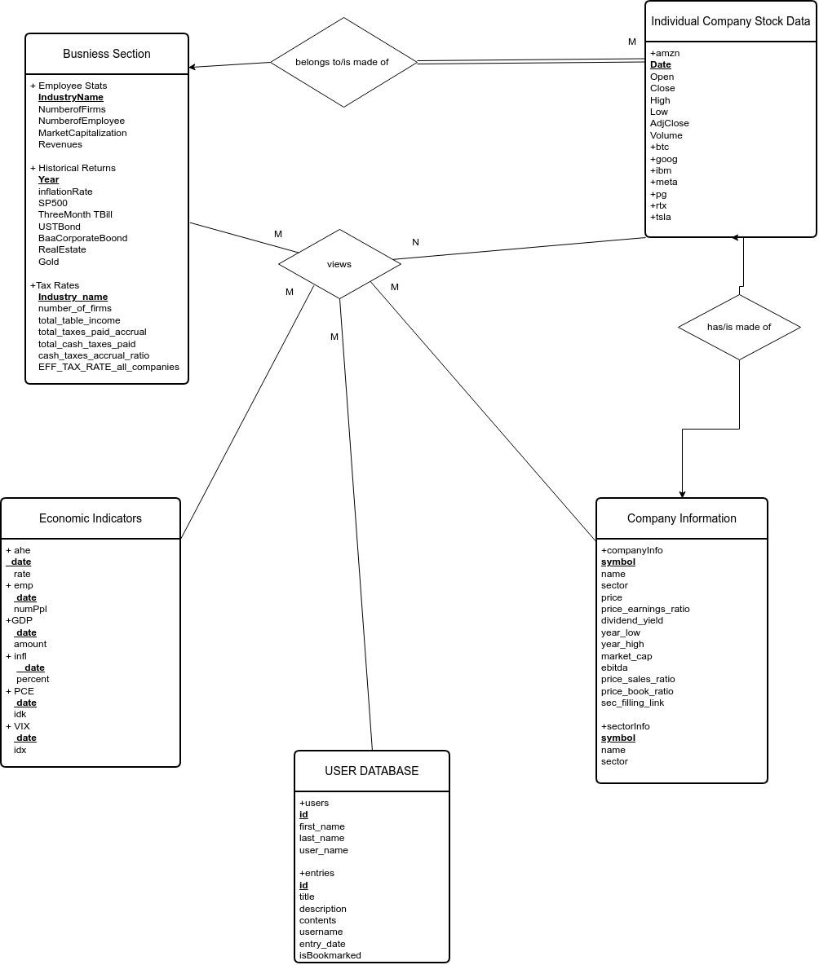

Additional:

Anything else you would like to see is in the drive folder shared with you.

<https://drive.google.com/drive/folders/1LF_QKsNZWN0eiMV8Drzmi4QQG2uRDf_o?usp=share_link>

Function Description for Front end– see video

Tables– see video

Source codes and SQL commands– see video and attached source code

Participation and Presentation– done in class

Record a video to introduce your project, how to click the button, and illustrate your code–attached